FOR IMMEDIATE RELEASE
Sept. 16th, 2022
Contact: Thia Muilenburg, Media Consultant
Phone: (561) 529-6655
Email: info@allegramiles.com

Allegra Miles Announces October Tour
Singer-songwriter Allegra Miles, a finalist on both NBC’s The Voice and American Idol, announces a tour with her band October 2022.
Allegra is thrilled to be opening for alt-pop singer-songwriter, BabyJake, on his “Nothing Like a Lady Dressed in Red 2022 Fall Tour.”
Since performing this year on Idol, Allegra has been hard at work creating new music in LA and Nashville, some of which will be on her upcoming EP. These songs will showcase a fresh dimension of Allegra’s sound, inspired by indie-pop, r&b, and singer-songwriter styles.
This will be Allegra’s first time on the road — fans will hear unreleased music, reimagined in a live setting with her band. She loves to be very free and fluid when playing live, morphing into eclectic jams and unexpected grooves throughout.
She’ll be joining BabyJake for his first 8 shows in 4 states. Tickets for these shows are available at https://www.itsbabyjake.com.
Oct 7th - Jacksonville, FL - Underbelly - 8pm
Oct 10th - Tampa, FL - New World Brewery - 8pm
Oct 11th - Gainesville, FL - High Drive - 7pm
Oct 12th - West Palm Beach, FL - Respectable Street - 8pm
Oct 13th - Orlando, FL - Henao Contemporary Center - 8pm
Oct 15th - Atlanta, GA - Center Stage - 8pm
Oct 16th - Greenville, SC - Radio Room - 7pm
Oct 17th - Charlotte, NC - Neighborhood Theatre - 8pm

About Allegra
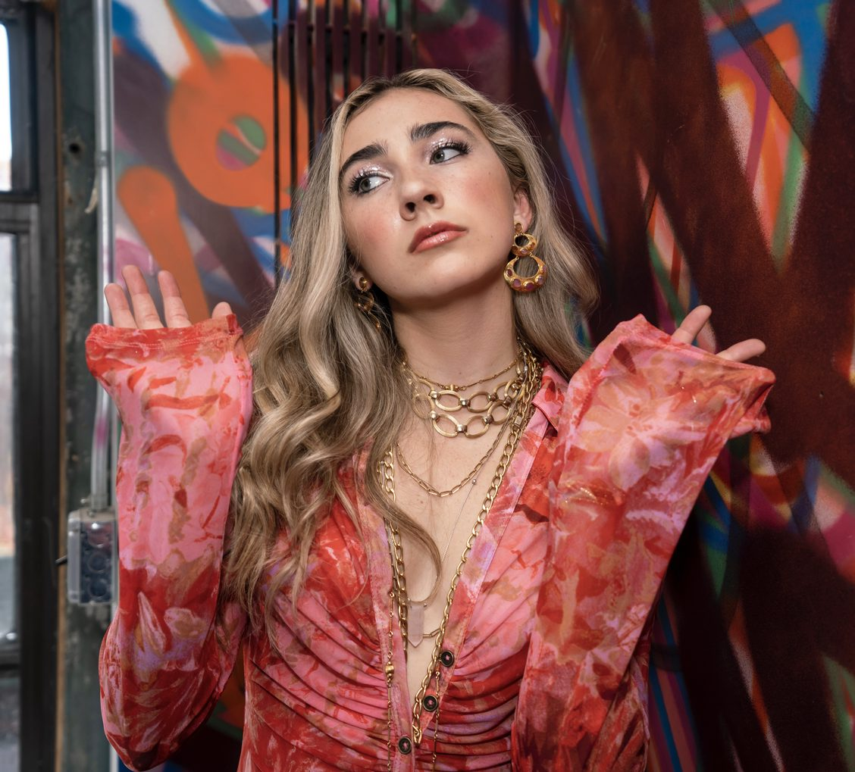
Allegra Miles is a singer/songwriter based in Los Angeles and West Palm Beach, FL. Born in San Diego, she then spent 5 years living on St. John, U.S. Virgin Islands before moving to Florida in 2014.
She has a distinct, recognizable sound that creates an atmosphere and makes you feel something. Her original music draws inspiration from soul, alternative, R&B, and singer-songwriter styles.
Allegra is a multi-instrumentalist who regularly releases original music and performs nationally. She was a finalist on NBC’s “The Voice” and “American Idol.”
Allegra is managed by Jay Cohen of Preach Co.
Please contact info@allegramiles.com for more info.
Stream Allegra's Music
www.AllegraMiles.com
Copyright (C) 2022 Allegra Miles Music. All rights reserved.
Allegra Miles Music
PO Box 33221
West Palm Beach, FL 33410-3221

